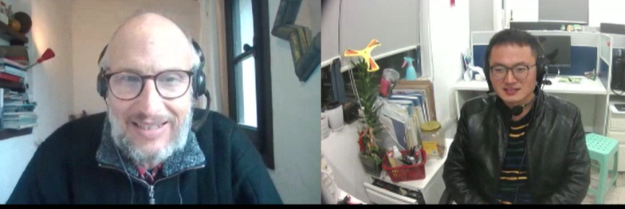

Sorry, I didn’t quite catch that.

Would you mind repeating that question, please?

Sorry, I didn’t fully understand your question, do you mind rephrasing it?

I don’t know if I understood correctly, did you mean..?

I’m sorry. I still didn’t understand. Could we talk after my presentation?

Thanks for asking that question. I think a lot of people may be wondering why I chose that approach. At first, I had actually thought to use a different type, but after a few trial/tests, I realize the mixed method was the best fit for my study.

